Section9:containers

1.docker container

-create a new directory

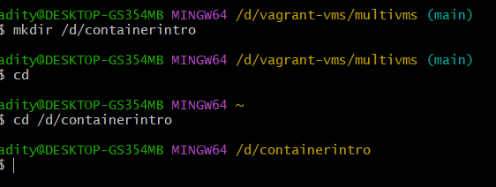

-place the vagrant file from the resource

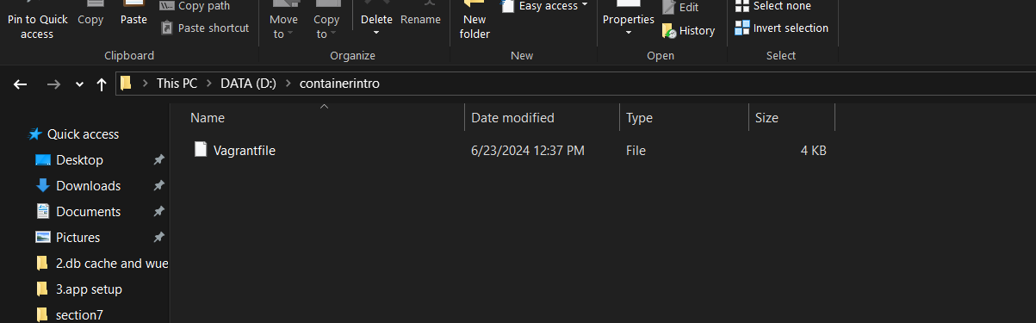

-the vagrant file used is ubuntu10

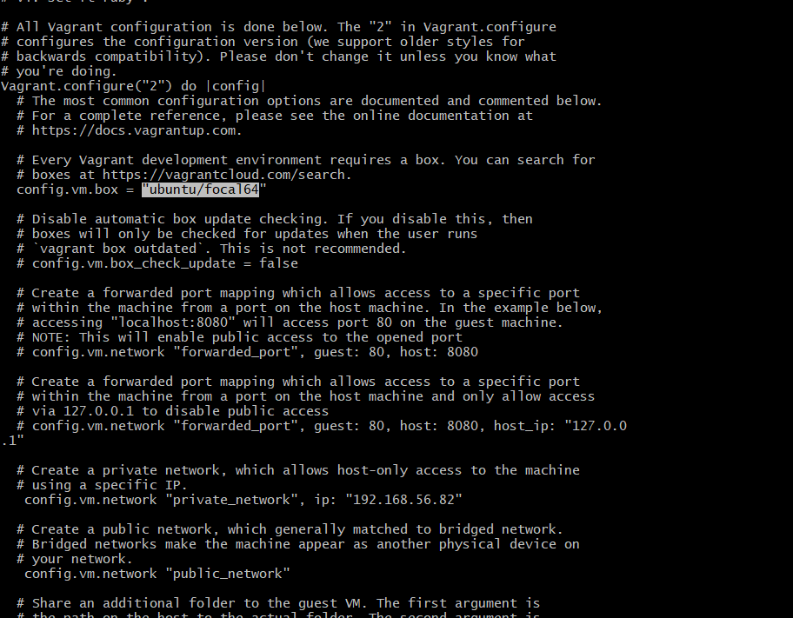

-provisioning cmds will install docker

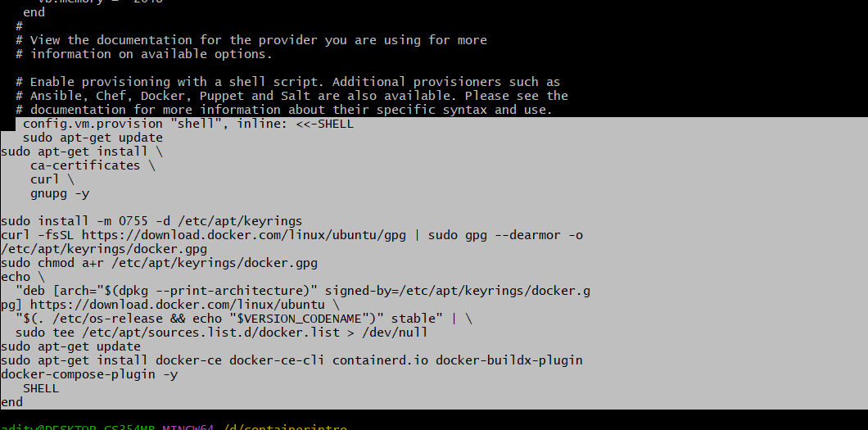

-refer this for the steps and cmds

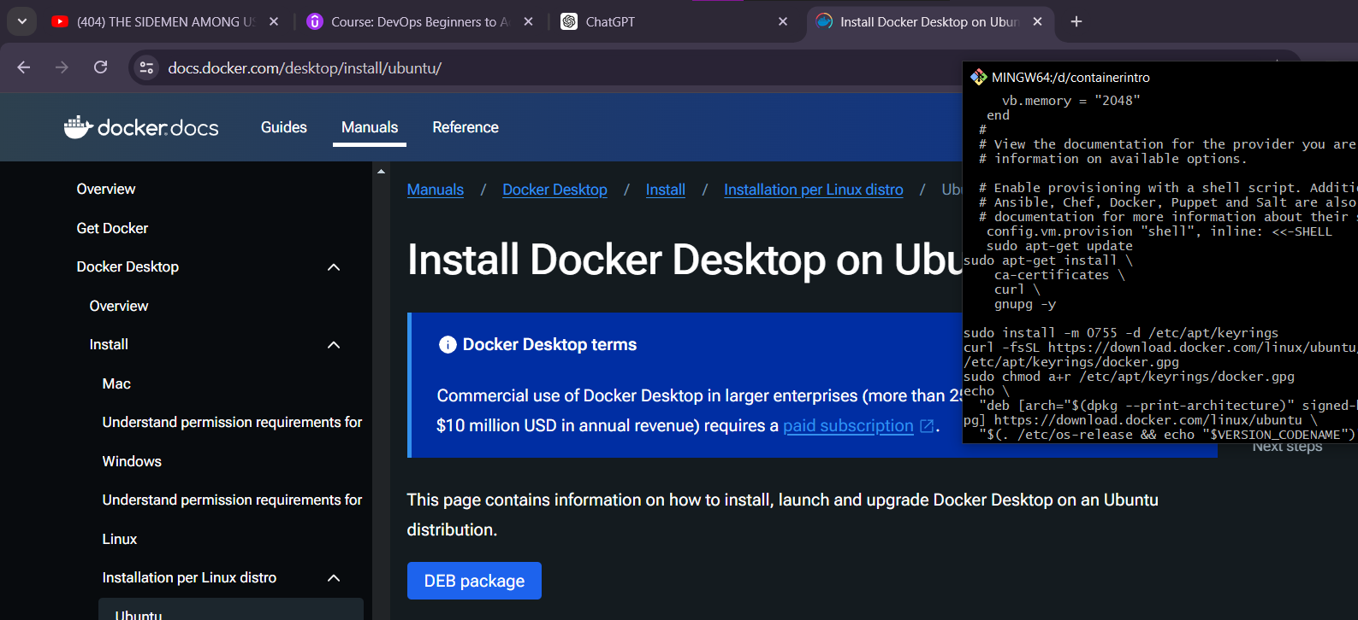

-check whether docker is running properly or not

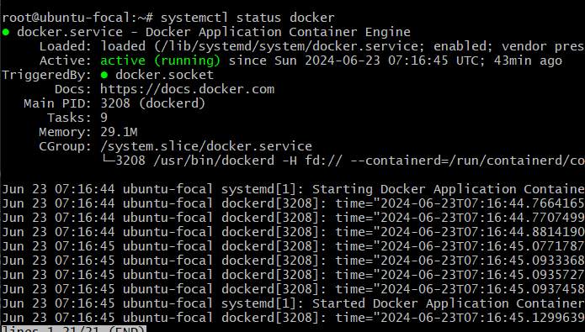

-unable to find locally so it searches globally

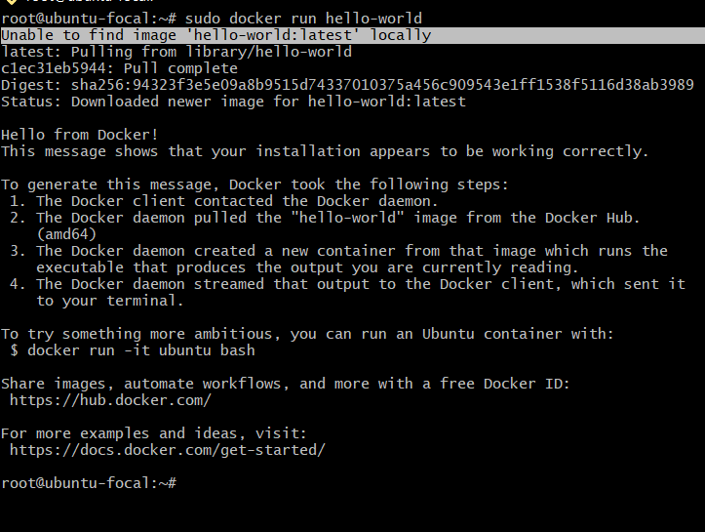

-creating another docker with port number and nginx image

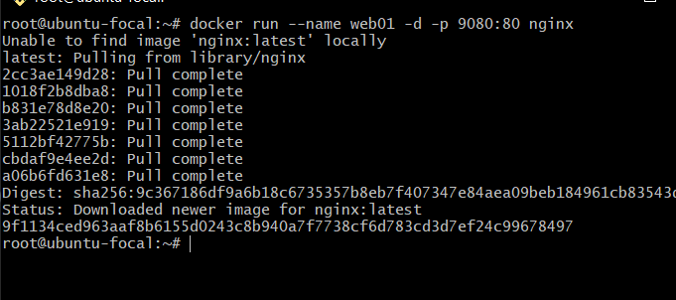

-u can see the docker up and running

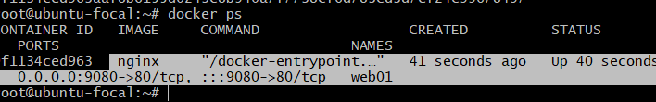

use this cmd to note down ip and container port

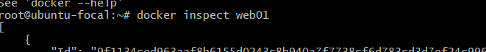

-ip

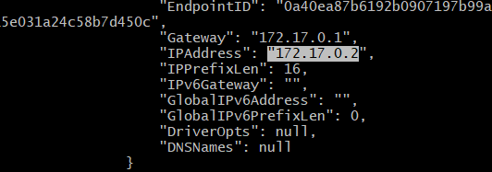

-web page

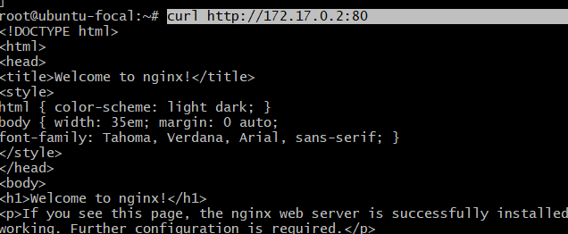

-ip with port number

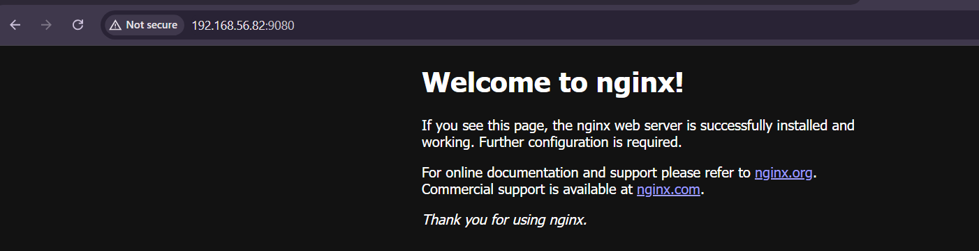

-creating our own docker image

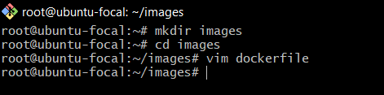

-docker file content from gpt

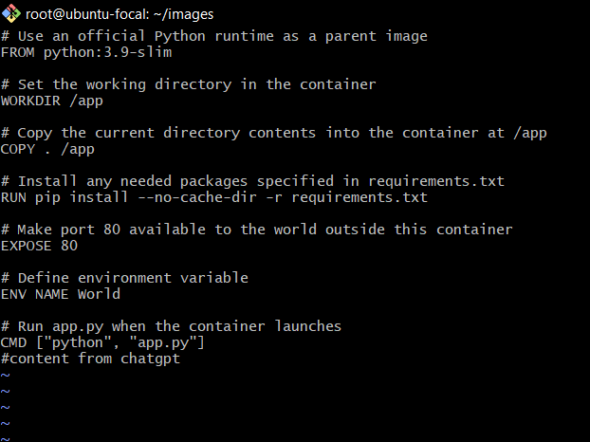

-to build our image

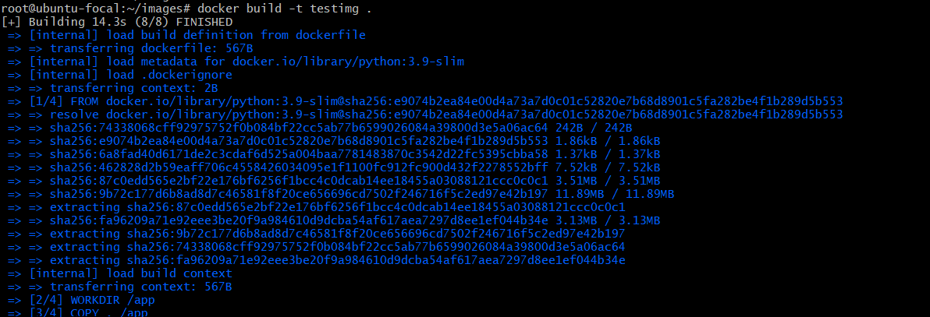

-we can see our image here

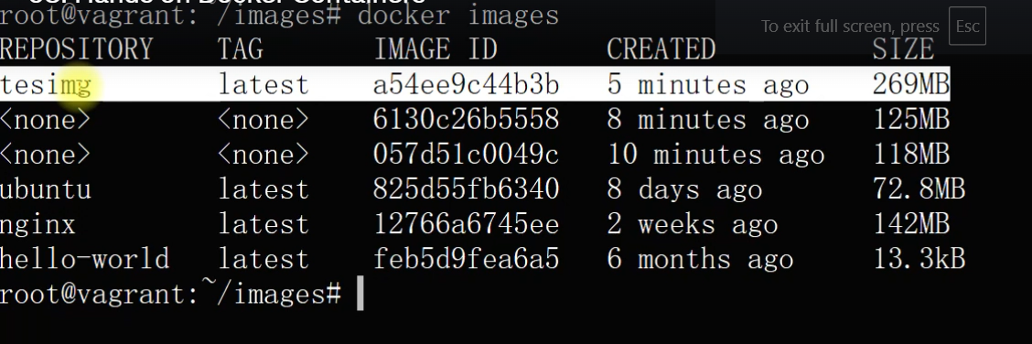

-highlighted is the port number

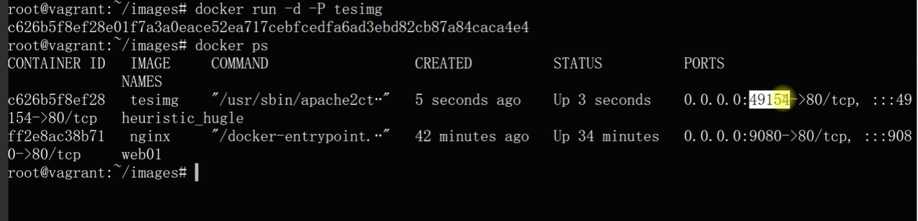

-copy ip and port no and paste it in browser

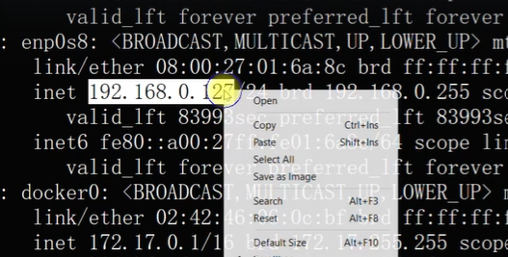



-to stop a container

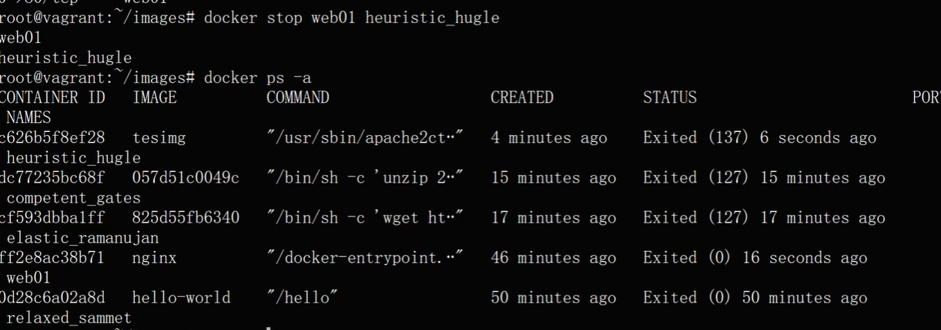

2.vprofile project

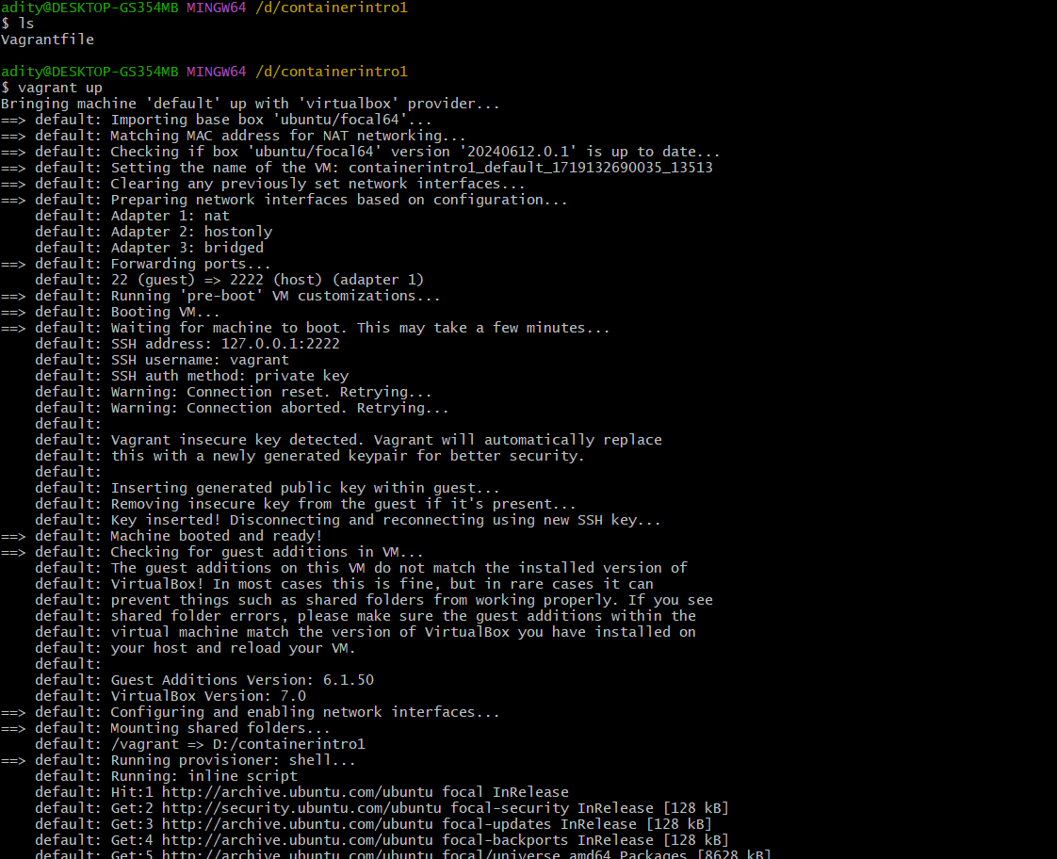

-if u wanna run multiple docker together

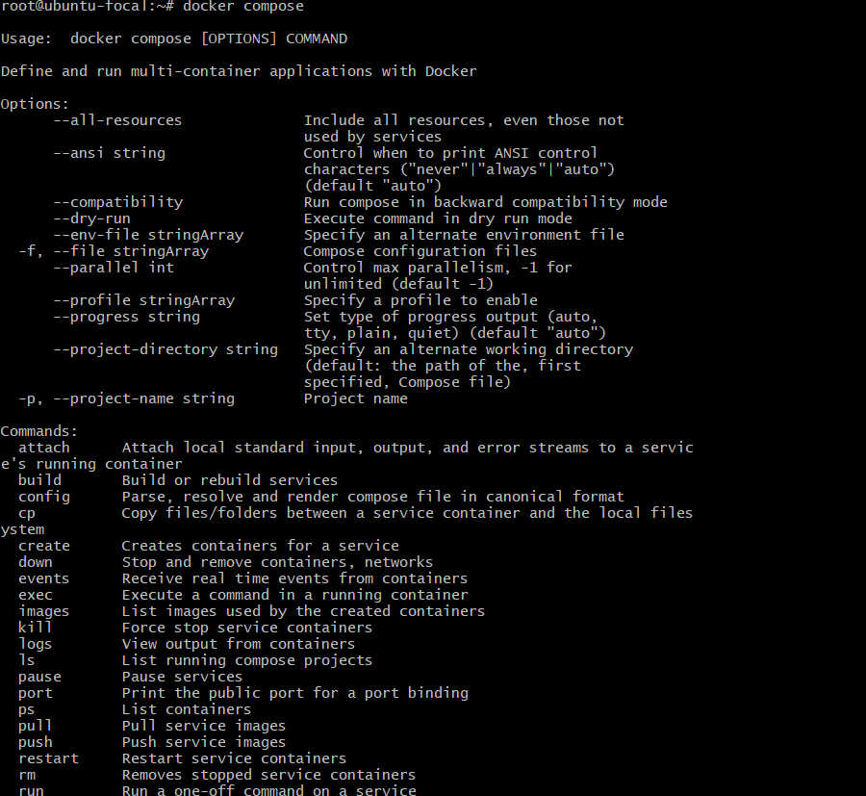

-search docker in github repo

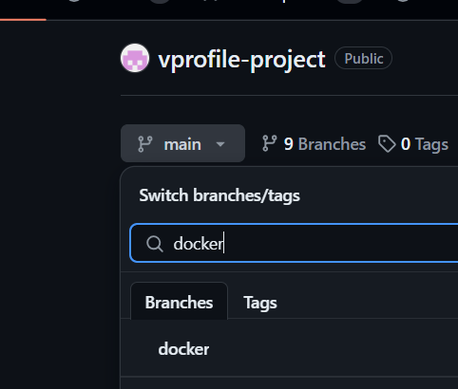

-open is YAML file as RAW

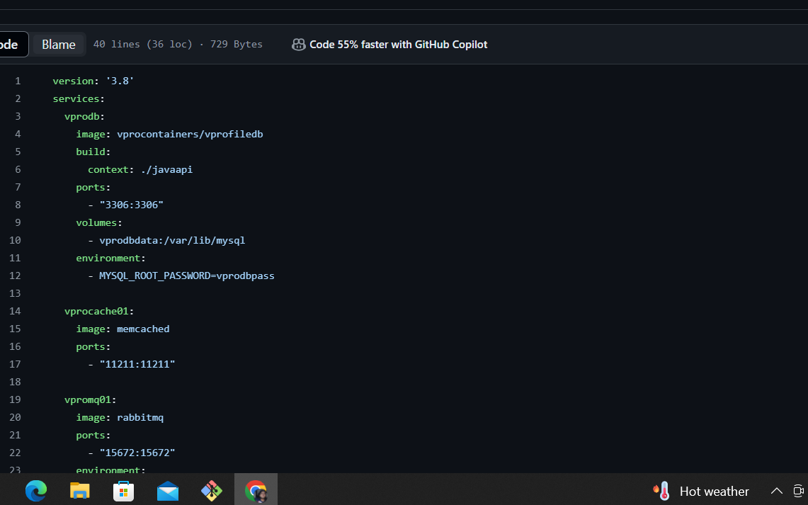

-the file is from here

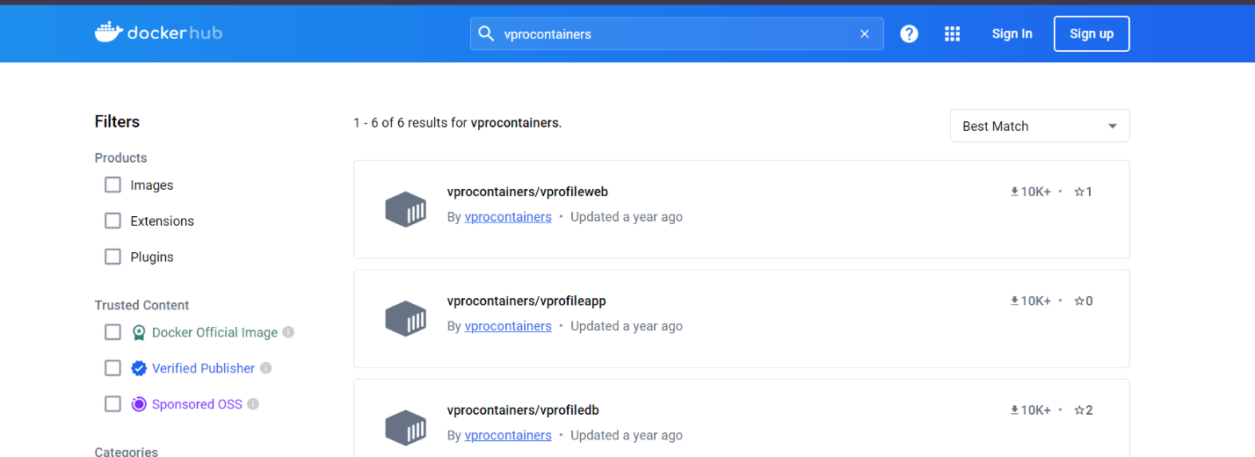

-go to raw btn and copy the link

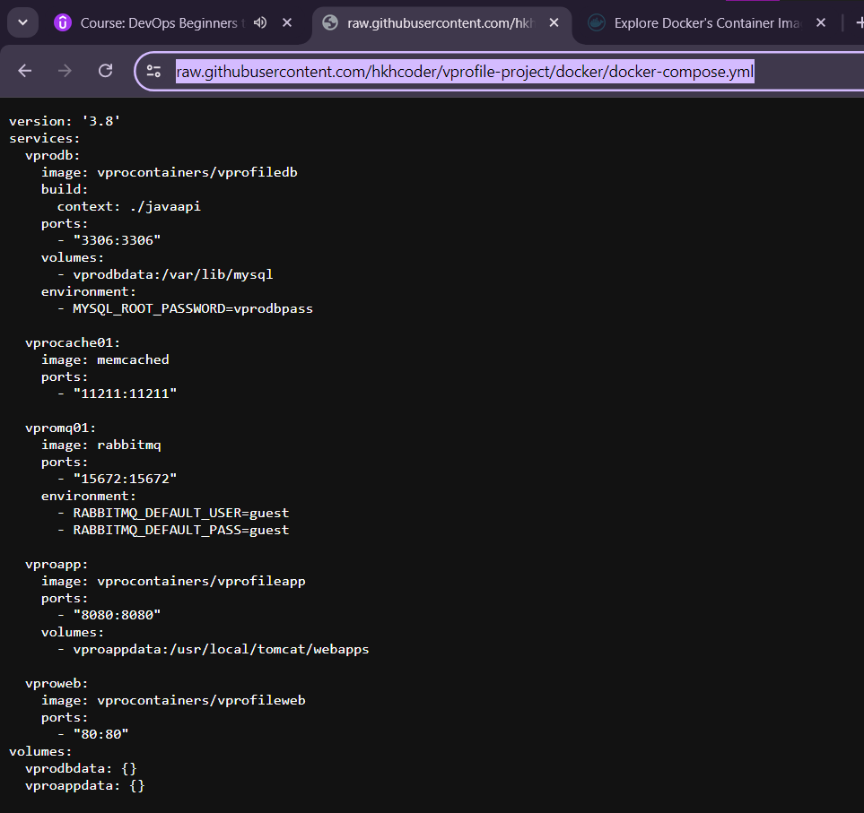

if file does not open then create a new dir compose and create a new file and paste the copied text int he file

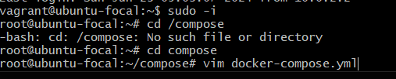

-copy and paste the vagrant file content

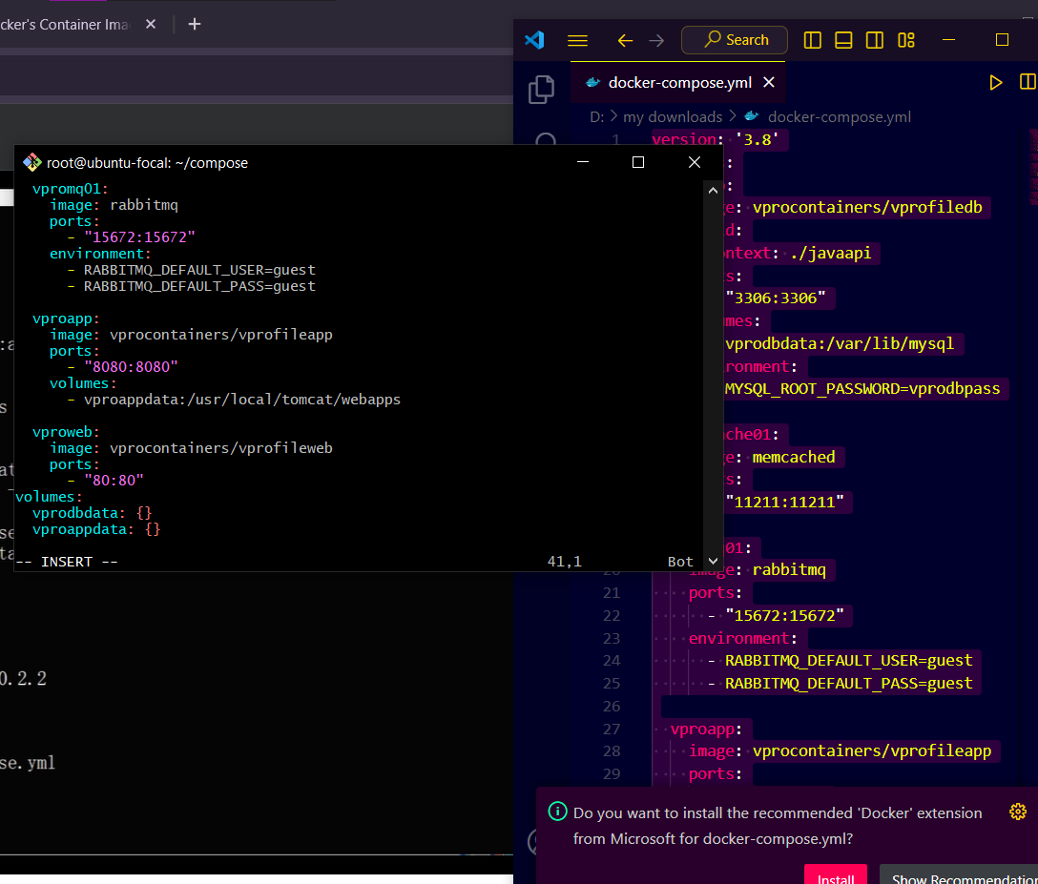

-this will be downloadede at the background

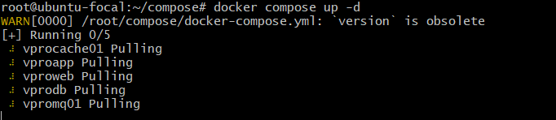

we can see 5 docker are create and images are running

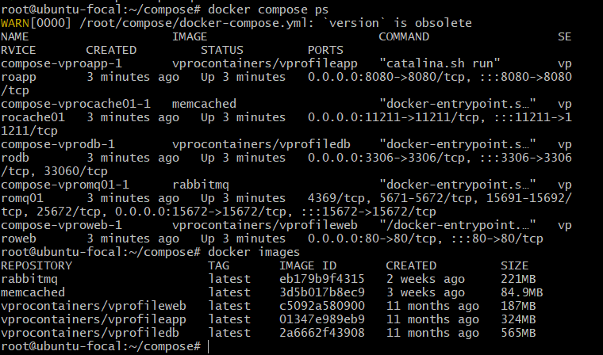

-copy the ip address

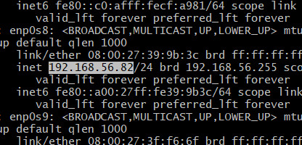

-we can see the website

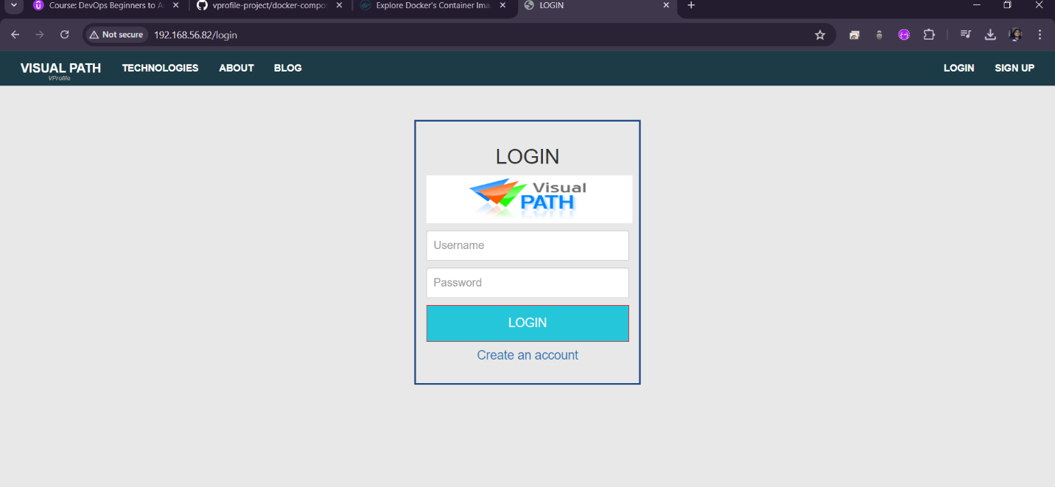

-to delete docker compose it down

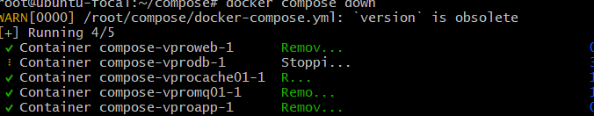

3emart project

